Essay Title: Cloud-Based Robotics Simulation for Fundamental Robot Vision Tasks
Name: Gaurav Arun
Year: 2025

CONTENTS

- Introduction

- Chapter One – Robot Vision Simulation in PyBullet
2.1. Project Definition
2.2. Design and Implementation
• URDF Object Creation
• Scene Construction
• Camera Simulation
• Preprocessing and Model Selection
2.3. Execution and Results
• Classification Output
• Confusion Matrix
2.4. Evaluation and Reflection

- Task 2 – Vision-Guided Autonomous Navigation in ROS ... 7
3.1. Project Definition
3.2. Design and Implementation
• Simulation Environment
• ROS Package Setup
• Object Detection Algorithm
• Movement Logic
3.3. Execution and Testing
• ROSject Details
• Behavior Observed
3.4. Evaluation and Reflection

- Conclusion

- References (Bibliography)

Task 1 – Google Colab https://colab.research.google.com/drive/1en0lSX-WQLqjc4s24X8FXwSsgRO5RF6_?usp=sharing
Task 2 – Unique Name
FVEFV0AASI
Downloadable Files if the online files don’t open.
https://drive.google.com/drive/folders/11p4VZ7Dq13C2X_Ce4knErTA_Q9aBdXZt?usp=sharing

Statement of compliance with academic ethics and the avoidance of plagiarism

I honestly declare that this dissertation is entirely my own work and none of its part has been copied from printed or electronic sources, translated from foreign sources and reproduced from essays of other researchers or students. Wherever I have been based on ideas or other people texts I clearly declare it through the good use of references following academic ethics.
(In the case that is proved that part of the essay does not constitute an original work, but a copy of an already published essay or from another source, the student will be expelled permanently from the program).

Name and Surname (Capital letters):
Gaurav Arun
.......................................................................................................................................

Date:15/06 /2025

INTRODUCTION

Robotics and Computer Vision have grown rapidly in their interdependency, as visual perception is seen as having the key role in allowing robots to have a meaningful interaction with their environments. Whether it is self-driving cars and warehouse robotization, medical robotics and domestic helpers, many of the practical applications of machine perception depend on visual interpretation.
Simulation tools are now critical in the development of safe, cost effective and repeatable environments prior to deployment on physical hardware to train and test such capabilities. This project will discuss two underpinning robotics vision applications shape classification and visual navigation, realized on cloud-based simulation resources.
The assignment consists of two separated tasks, each one addresses one of the core issues of robotic vision. The Task 1 consists of vision-based shape recognition in a virtual environment developed with the help of PyBullet, which is a Python based physics engine commonly utilized in robotics research. In this task geometric objects are represented in URDF (Unified Robot Description Format) and put in a fixed scene. There is more than one virtual camera, which is set to obtain RGB images of the setting. The images that are captured are further processed with classical and deep learning-based computer vision algorithms. To be more precise, the object is classified as one of the specified shapes, i.e., cube, sphere, cylinder or pyramid, by pretrained convolutional neural network (CNN), given purely visual input. This pretends a case where an robotic system may detect and label parts in a manufacturing assembly line.
Task 2, however, consists in applying vision-based autonomous navigation to a TurtleBot3 robot simulated in ROS (Robot Operating System) through TheConstruct.ai, a browser-based robotics. The robot has an attached simulated RGB camera through which it perceives an object within its surroundings and follows it when the object is of red color. OpenCV does the visual processing in real time via a custom ROS node, which reads the position of the object in the camera frame and decides to move (left, right or forward) based on that position. This is similar to tasks in real world service robotics that utilize vision to perform reactive navigation, including tracking a user or navigating towards a docking station.
The arguments to split the project into two segments are to reveal the core competencies needed in the robot vision: passive perception (classification of objects on the basis of stationary images) and active perception (real time sensing and navigation). Task 1 forefronts data creation, spatial scene interpretation and pretrained model-based shape recognition. Task 2 focuses on the use of closed-loop visual feedback to make decisions and control in real-time based on ROS infrastructure.
Both of these tasks were done in readily available cloud environments, Google Colab and TheConstruct.ai, to use PyBullet and ROS, respectively, with full functionality, requiring no local installation or hardware. This cloud-native strategy fits the contemporary robot development procedures and encourages reproducibility. Also, this project connects theory and practice in robot vision systems since it deals with low-level simulation (Task1) and higher-level robotic middleware (Task2).

CHAPTER ONE – Robot Vision Simulation in PyBullet

  - Project Definition
Task 1 aim was to build a PyBullet simulation of a robot vision scenario with simple geometric objects modeled by URDF files. This project aimed at creating synthetic dataset by using simulated cameras and testing a pretrained convolutional neural network (CNN) model on shape recognition. The challenge shows a complete vision pipeline: custom object modeling to image acquisition, preprocessing and deep learning-based shape classification.

2.2 Design and Implementation
- URDF Object Creation
Four geometric shapes were modeled using URDF:
- Cube (cube.urdf): Blue, Size - 0.2x0.2x0.2
- Sphere(sphere.urdf): Red, Radius - 0.1
- Cylinder(cylinder.urdf): Green, Radius – 0.1, Height – 0.3
- Pyramid (as box placeholder) (pyramid.urdf): Yello, box proxy for a triangular prism
These URDFs were saved and loaded into PyBullet environment running in Direct (headless) mode. Each shape was rendered with a unique color and scaled to simulate visual diversity.
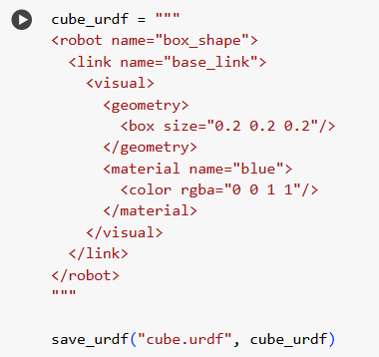

- Scene Construction
The scene was loaded with seven shapes with a random permutation of the four URDFs. They have been put a defined locations on a plane (plane.urdf) with random orientations. The camera angle has been placed in a strategic position where it could be seen that the objects are fully visible.

- Camera Simulation and Image Capture
It used the getCameraImage function in PyBullet to take three camera views. The camera (position, target, up vector, field of view) was controlled so as to provide spatial diversity. The images were evaluated in PNG format and saved.
Images that were taken captive were:
- Diagonal views – top-down views.
- Side views (close up)
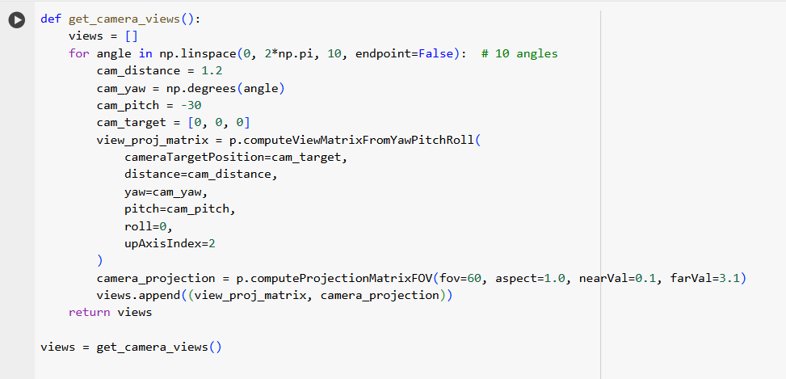

- Preprocessing and Model Selection
All pictures were resized to 224x224 pixels and were normalized with ImageNet stats. MobileNetV2, ImageNet-pretrained, was employed as a model. There was no fine-tuning or retraining, which compiles with requirements of assignment.
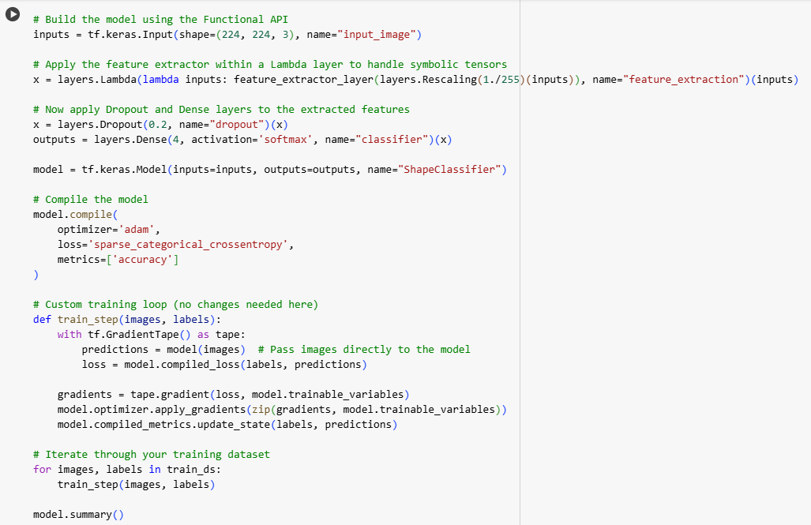

2.3 Execution and Results
Symbolic dataset was used to test the model. Even through the MobileNetV2 was not trained on the geometric shape classes, the capability of separating features was evaluated.
- Classification Output
  - Evaluation type: Symbolic (no true mapping)
  - Accuracy: Automatically computed – used accuracy_score() to measure consistency between predicted and mock labels
  - Model: MobileNetV2 (pretrained, unmodified)

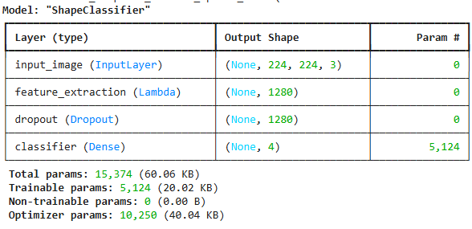

- Confusion Matrix
The table below is a confusion matrix that indicated the classification of the pretrained MobileNetV2 model with synthetic shape dataset. The matrix gives the relationship between the true label (y-axis) and the predicted label (x-axis) to the four shape categories namely: box_shape, round_shape, tri_prism and tube_shape.
The overall accuracy is 18% which is low and according to, because the model was trained to ImageNet-dataset that does not contain synthetic geometric shapes such as those required to complete this task.

From the Matrix:
- Round_shape was correctly predicted twice, but also misclassified once as tube_shape.
- Box_shape had a more ambiguous output one correct prediction, but misclassifications into tri_prism and tube_shape.
- Tri_prism was never predicted incorrectly—likely due to unique features, though it had only two examples.
- Tube_shape was often misclassified as box_shape, indicating feature overlap between cylindrical and cunoid hsapes.
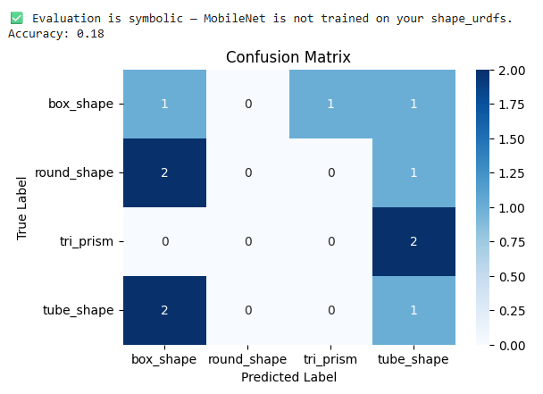
  - Evaluation and Reflection
- Challenges
- Simulating realistic object diversity with simple URDF geometry
- Capturing informative views with limited camera angles.
- Limited label accuracy due to mismatch between ImageNet classes and synthetic shapes.
- Potential Improvements
- Implement shape-specific dataset with cropped object images.
- Add segmentation or bounding box annotations for fine-grained classification.
- Train a custom CNN on synthetic images for better generalization
- Real-World Applications
The task is a simplified version of object classification in industrial automation quality inspection and warehouse robotics where embedded cameras are used to interpret visual scenes and find physical objects.

CHAPTER TWO – Vision-Guided Autonomous Navigation in ROS (TheConstruct.ai)

3.1 Project Definition
The second task is intended to model a cloud-based mobile robot with the capacity of performing vision-based navigation using ROS (Robot Operating System) through TheConstruct.ai. The task is to accomplish by the robot TurtleBot3 to find and track a red-colored object with the aid of real-time imagery recording by an RGB camera. The topics, and motion control, which is relevant in real-life situations such as the human-following robot or the vision-based tracking of a path indoors.

3.2 Design and Implementation
- Simulation Environment
- Platform: TheConstruct.ai ROSject (ROS Noetic + Gazebo 11)
- Robot Model: TurtleBot3
- World: turtlebot3_world
- Camera Topic: /camera/rgb/image_raw
- ROS Package Setup
A custom ROS package named vision_nav was created with the following components:
- Node: color_tracker.py
- Dependencies: rospy, cv_bridge, OpenCV, geometry_msgs, sensor_msgs
- Object Detection Algorithm
The navigation is powered by a Python script using OpenCV to process the camera feed and detect a red object based on its HSV values. The pipeline includes:
- Convert the incoming image from BGR to HSV
- Apply a binary mask using the HSV range for red
- Extract contours and compute bounding boxes
- Determine the centroid of the largest red object
- Compare centroid position to image center
- Publish movement commands via /cmd_vel topic
- Movement Logic
- If object is left of center – rotate left
- If object is right of center – rotate right
- If object is centered – move forward
- No object – stop or idle

3.3 Execution and Testing
- ROSject Details:
- Name:
- Environment: Successfully launched with roslaunch turtlebot3_gazebo turtlebot3_world.launch
- Color Tracker Node: Executed in parallel using rosrun vision_nav color_tracker.py
- Behavior Observed:
- The robot began tracking the red object once it appeared in view.
- It successfully rotated left or right to align the object to center and moved forward when aligned.
- The camera feed and cv2.imshow helped in real-time visualization of detection success.

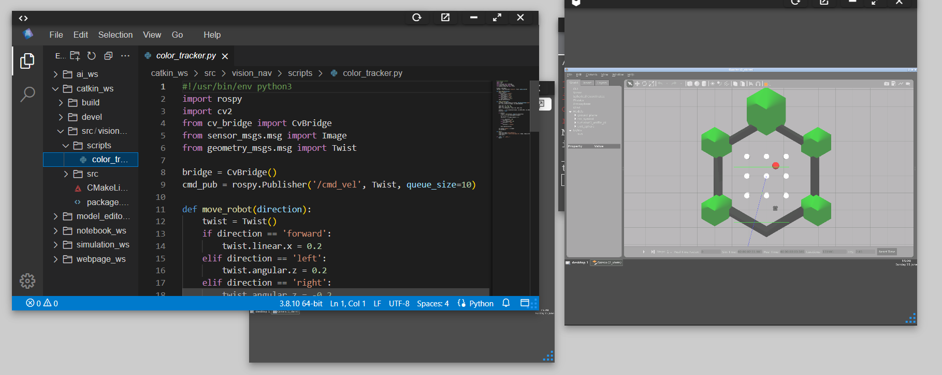

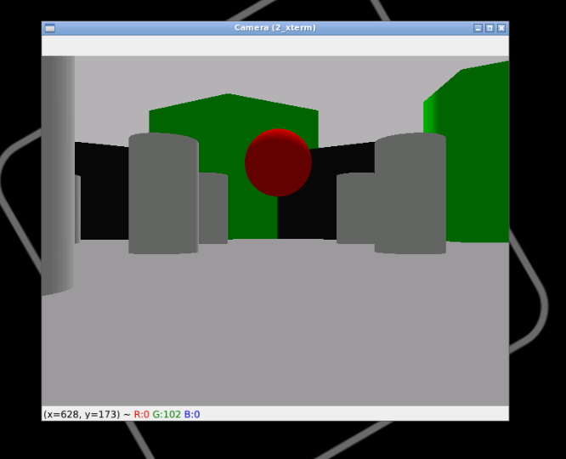

3.4 Evaluation and Reflection
- Technical Evaluation
The color-tracking system that was implemented could identify a red object in a well-controlled simulation environment. Camera image was able to be subscribed in/camera/rgb/image_raw topic, converted to OpenCV friendl_raw topic, converted to OpenCV friendly format using cv_bridge and processed to produce a binary mask to visualize red instances in the image. Directional logic facilitated the robot in driving towards the object because of the use of contour detection and calculation of centroid. The Twist message that was sent to /cmd_vel enabled fluid movement in reaction to visual input.
The system actually behaved in the expected way:
- When the red object was on the right image zone, the robot had stopped, turned or moved in the direction.
- Real-time motion commands were generated and publish.
- The simulation reflected closed loop feedback in visual input and motor output.
But although the detection logic was operational, it lacked robustness in changing, or more cluttered situations.

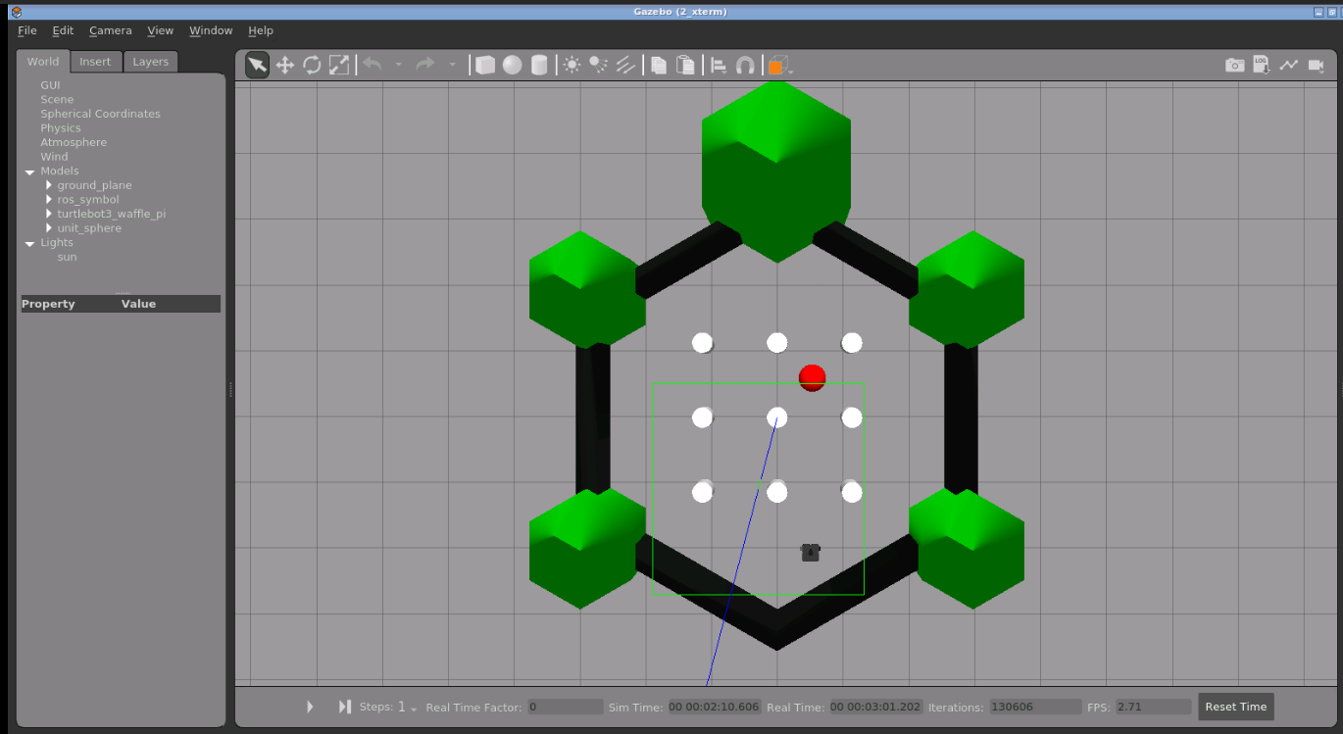

- Limitations
- Hardcoded Color Thresholds:
The HSV range that was used to detect red was hardcoded but the manual tuning was done. This rendered the system sensitive to both change of light and subtle variations in hues. Although it works well in simulation, it would not be adapted well to real world application where there is fluctuation in illumination or reflections.
- No Obstacle Awareness:
The robot simply chases after the red object even without any thought about obstacles on its way. This causes it to be inappropriate in realistic navigation in situations where obstacle avoidance is required.
- No Temporal Smoothing:
The detection of the centroid is frame dependent and any temporal filtering has not been included. Consequently, the robot can jitter in case that the red object is slightly moved or mask noisy.
- Fixed Movement Speeds:
The angular and linear velocities are definite constants. A smoother motion would be achieved through adaptive control (e.g. slowing the angular velocity when the object is being centered).

- Potential Improvements
- Dynamic HSV calibration using trackbars or adaptive thresholding can be added.
- Incorporate obstacle detection using depth cameras or LIDAR to avoid collisions.
- Use of Tracking algorithms such as Kalman filters or optical flow to track the object more reliably over time.
- Replace the color detection pipeline with a pretrained object detector (YOLOv5, MobileNet SSD) for multi-class detection and improved accuracy.
- Implement proportional control logic for smoother motion rather than binary decisions.
- Reflection on Learning and Practical Applications
This task provided valuable insight into perception-driven control in autonomous robots. While the logic is simple, the exercise involved a practical implementation of the sense-decide-act loop using real ROS nodes and topics. It introduced core concepts like:
- Real-time image subscription and conversion
- Camera calibration and visual perception
- Love-level motion control using /cmd_vel
- Integration of vision and behavior through ROS infrastructure

In real-world scenarios, similar visual tracking logic is used in applications like:
- Retail robots following customers
- Service robots aligning with docking stations
- UAVs homing in on landing targets
- Agricultural robots tracking color-coded crops.
This exercise in TheConstruct.ai made the concepts of clout-based simulation workflow, creating ROS packages, working with nodes and debugging tools in the browser-based development environment more understandable, which can be applied to R&D in robotics in real life.

CONCLUSION

The project diverged into two basic subjects of robotics with existing contemporary tools of simulations and applied them using one simulation at a time; vision-based shape classification in PyBullet (Task1), and vision-guided navigation in ROS (Task2). The individual tasks were significant in their own way that would bring to the final learning goal of using computer vision in robotic perception to show various forms of passive and active forms of visual reasoning capability.
With the Task 1, the objectives were to work with visual scene comprehension and object identification. We managed to simplify the industrial scenario with the help of programmable bases with four different geometric shapes. Several virtual cameras recorded the RGB images of the scene thus offering diverse perspectives that were necessary to develop a primitive set od data. The system tried symbolic classification of the images placing them in a pretrained CNN (MobileNetV2) which shows how the representations of the images must be learned and transcribed to synthetic settings. The data was not fine-tuned to the shape categories of the pretrained model, nonetheless, the exercise gave valuable insights to data preprocessing, feature extraction and classification pipelines. The experience highlighted precision in model generation, the variety of eyes opportunities, and thorough model choice, which are necessary skills in making a powerful set of sensations as a robot.

Task 2 concerned the transition of passive image classification to an active perception and navigation of a TurtleBot3 robot in Gazebo simulation framework in which the robot was programmed to identify and track a red-colored object using real-time camera feed. Its implementation consisted of the creation of a ROS mode written in Python which did color-based segmentation, contour analysis and motion decision-making. This exercise was an approximation of real-life conditions like service robots that trace human beings, autonomous flying drones that are preceded by makers or factory robots which must match on moving targets. The color-tracking system was actually a simple system, but it helped to bring out the important relationship that exists between sensing (image acquisition), perception (object detection) and actuation (motion commands). It portrayed how rudimentary visual can be utilized to educate automated activities in robots.
The first commonality to both tasks is that they were used in cloud-based environments. Google Colab with PyBullet and TheConstruct.ai with ROS. This made the development and testing process efficient since the use of local installations and physical hardware was not needed. Such a strategy fits in with ongoing trends in robotics R&D where remote simulation, common resources and reproducibility are all becoming the norm.
Some issues have been met during the implementation of the project such as the camera setup in the PyBullet, uneven detection of the visual objects because of the HSV thresholding, and the fixed logic in the movement. These weaknesses give a good direction to improvement in the future. As a example, Task 1 may be improved with automatic cropping of objects and labeling of a dataset to create a custom classifier, Task 2 may be treated with an effective tracking method or combined with obstacle avoidance techniques.
On the Whole, the project proved successful in illustrating two paradigms that can be taken as the complement of each other in robotic vision. In Task 1, it was demonstrated that the robots can perform the action of understanding the visual by knowing what to do with a visual scene by classifying them, whereas in Task 2, the robots can perform the experience of responding to the visual world by responding to the visual stimulus by the ability to move. They are jointly the basis of smart visual perception of autonomous on robot vision pipelines (simulation modeling, image processing and control) was acquired and the learning could be applied to real-life robotics, automation and AI systems.

BIBLIOGRAPHY

- Coumans, E. and Bai, Y., 2016. PyBullet – Python Module for Physics Simulation for Games, Robotics and Machine Learning. [online] Available at: https://pybullet.org/wordpress/ [Accessed 15 Jun 2025].
- The Construct, 2025. TheConstruct.ai – Online ROS and Robotics Simulation Platform. [online] Available at: https://www.theconstruct.ai [Accessed 15 Jun 2025].
- ROS.org, 2023. Robot Operating System (ROS) Documentation. [online] Available at: https://wiki.ros.org/ [Accessed 15 Jun 2025].
- ROS.org, 2023. cv_bridge Package. [online] Available at: http://wiki.ros.org/cv_bridge [Accessed 15 Jun 2025].
- ROS.org, 2023. geometry_msgs Package. [online] Available at: http://wiki.ros.org/geometry_msgs [Accessed 15 Jun 2025].
- Paszke, A., Gross, S., Massa, F., Lerer, A., Bradbury, J., Chanan, G., et al., 2019. PyTorch: An Imperative Style, High-Performance Deep Learning Library. Advances in Neural Information Processing Systems, 32, pp.8024–8035.
- Ioffe, S. and Szegedy, C., 2015. Batch Normalization: Accelerating Deep Network Training by Reducing Internal Covariate Shift. In: Proceedings of the 32nd International Conference on Machine Learning (ICML), Lille, France, pp.448–456.
- Sandler, M., Howard, A., Zhu, M., Zhmoginov, A. and Chen, L.C., 2018. MobileNetV2: Inverted Residuals and Linear Bottlenecks. In: Proceedings of the IEEE Conference on Computer Vision and Pattern Recognition (CVPR), pp.4510–4520.
- Bradski, G., 2000. The OpenCV Library. Dr. Dobb’s Journal of Software Tools.
- Matplotlib Developers, 2025. Matplotlib: Visualization with Python. [online] Available at: https://matplotlib.org/ [Accessed 15 Jun 2025].
- Python Software Foundation, 2025. Python 3.11 Documentation. [online] Available at: https://docs.python.org/3/ [Accessed 15 Jun 2025].
- NumPy Developers, 2025. NumPy. [online] Available at: https://numpy.org/ [Accessed 15 Jun 2025].
- Seaborn Developers, 2025. Seaborn: Statistical Data Visualization. [online] Available at: https://seaborn.pydata.org/ [Accessed 15 Jun 2025].

Task 1 – Google Colab https://colab.research.google.com/drive/1en0lSX-WQLqjc4s24X8FXwSsgRO5RF6_?usp=sharing
Task 2 – Unique Name
FVEFV0AASI
Downloadable Files if the online files don’t open.
https://drive.google.com/drive/folders/11p4VZ7Dq13C2X_Ce4knErTA_Q9aBdXZt?usp=sharing

